WordPress Client Manual
Welcome to the CMS for your website:
Your new website has been created using WordPress, a flexible tool used for building websites that allows you, as the user to make changes quickly and easily through your backend (CMS).

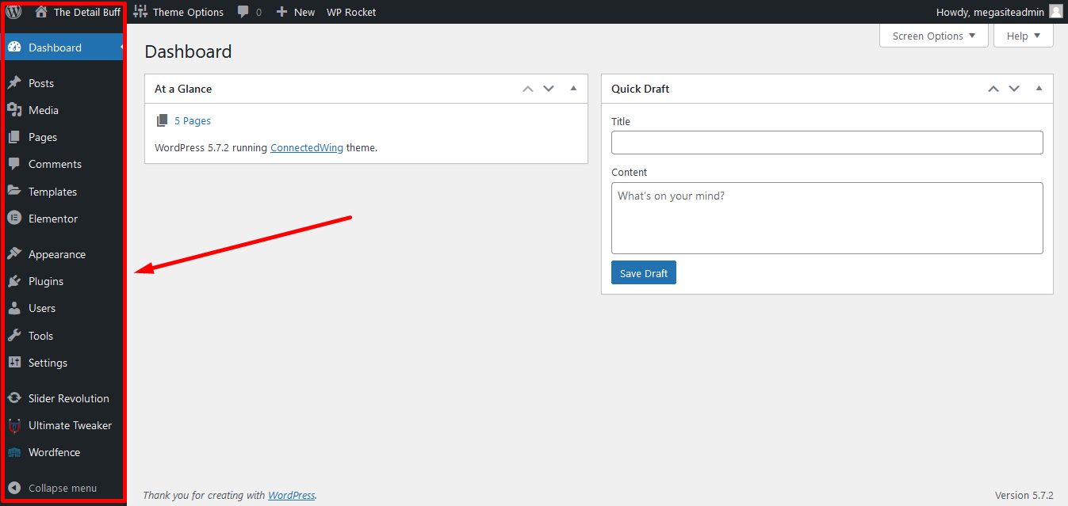
This is the first look of admin panel
Use this to edit your website

After you login to your word press site you see this panel which is known as Admin panel from which you can easily change content for you site. This is the Firstlook of admin Panel Use this to edit your website.

Menu View: All menu viewed to Admin after login
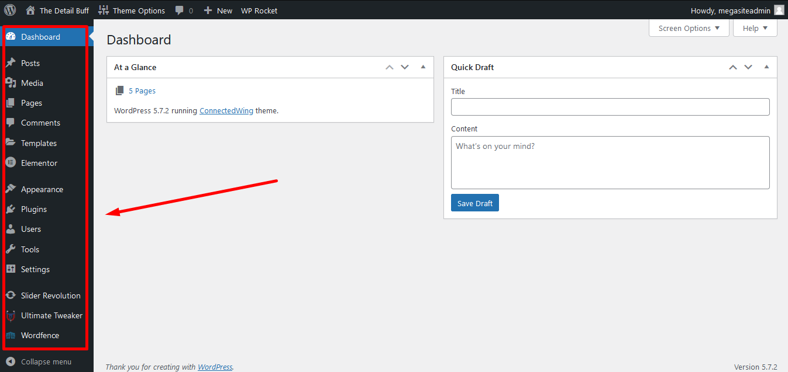
These menus are used to make changes in site

Editing Home Page and Pages:
User can easily change the content of the front-page using edit button on top bar and also other pages as well.
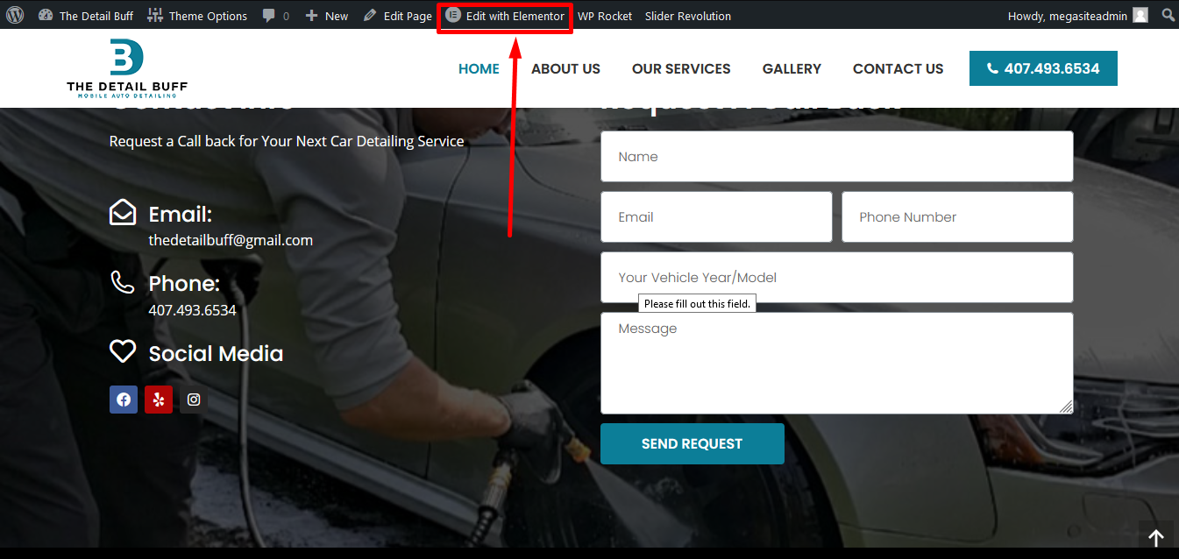
Edit existing page from here

Editing Pages:
User can easily change the content of the front page using edit button on All Page Options under Page Title.
Change background picture
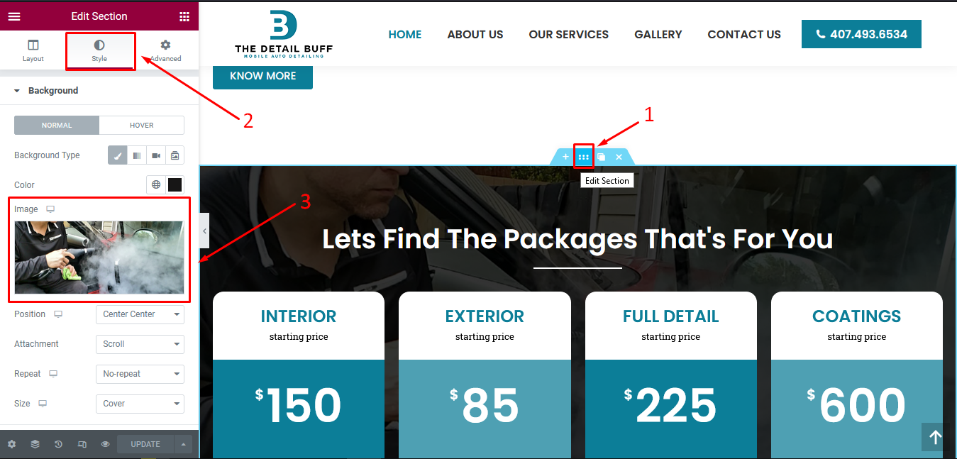

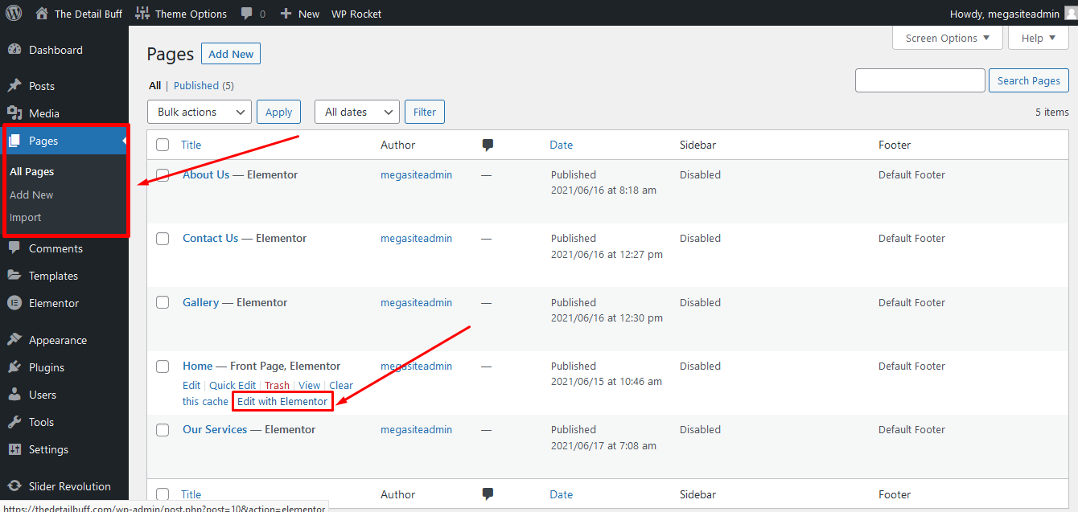
Edit any page from here
Edit pages from this menu
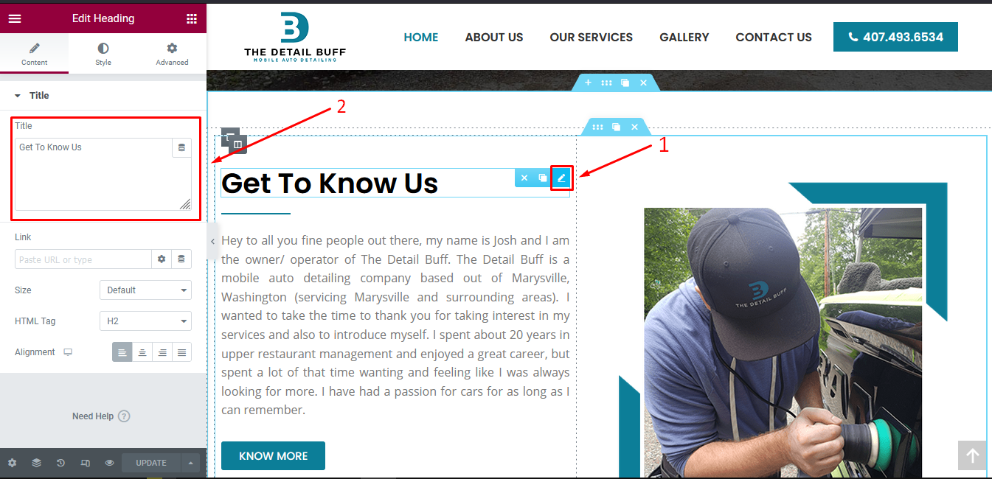
Hover on any element and click the pencil to edit that element

Editing the Slider:
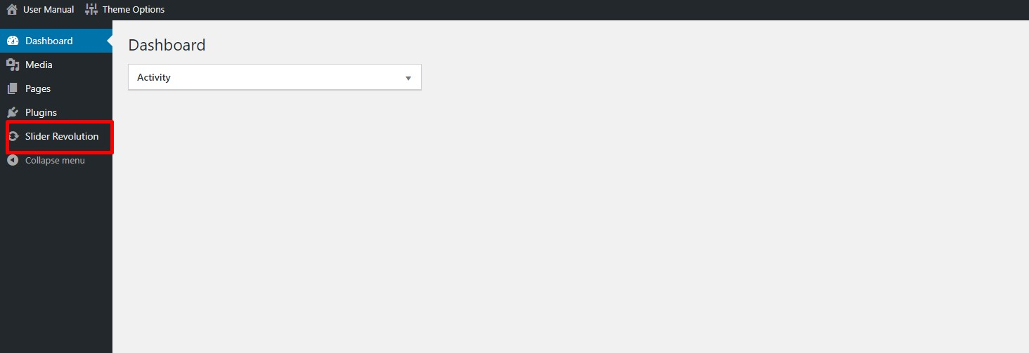
For making changes in slider, click on “Slider Revolution” from dashboard.

To Add/Edit Slider:

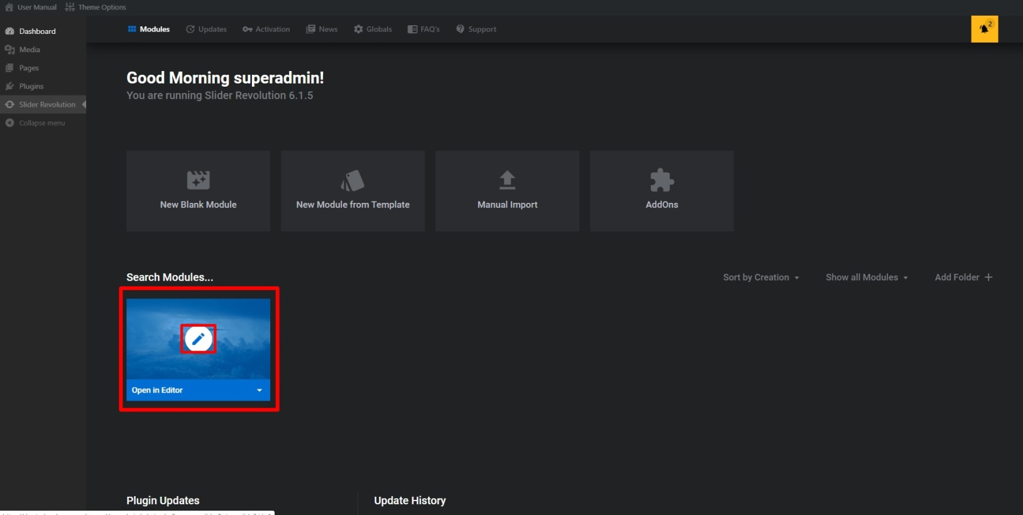
Here is dashboard for slider revolution. All sliders created will appear here. Choose slider where you want to make changes.

FOR CHANGING SLIDER BACKGROUND IMAGE:
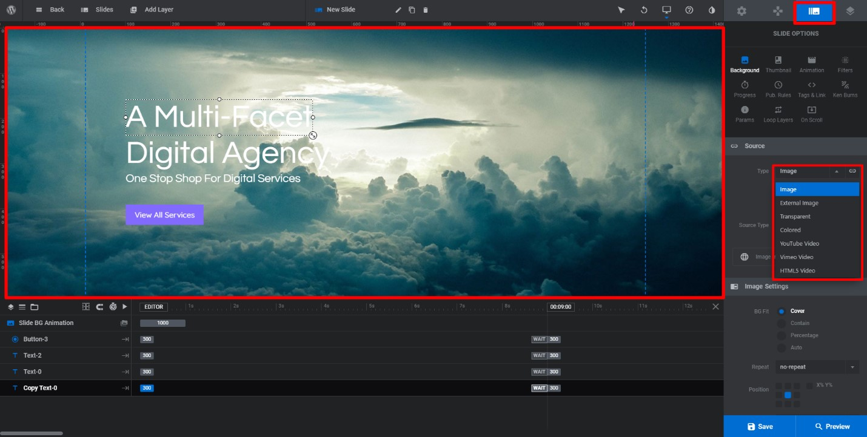
For changing slider background image. Click on highlighted icon on top right corner and click on “background”. From source panel, choose background type either it is video, external image or solid color.
For image, click on image.

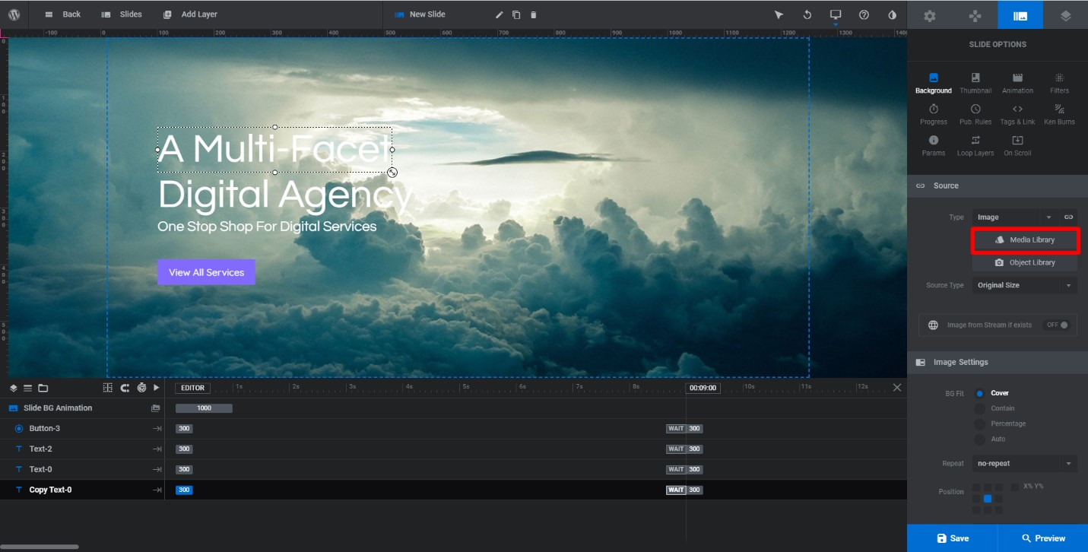
Choose image form media library.
Slider image from background will be updated.

Change TEXT OR BUTTON:

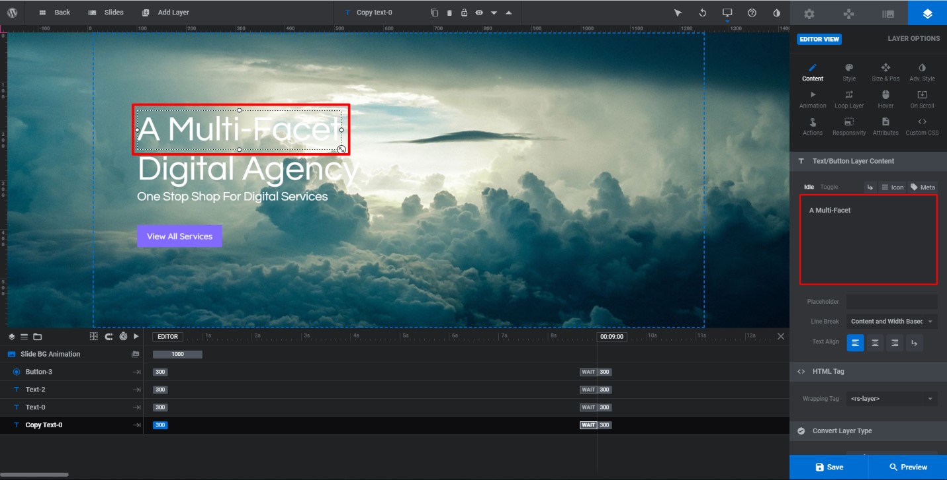
For text or button layers, simply double click on it to edit.
When you will click on text layer, options for text layer will become enabled.

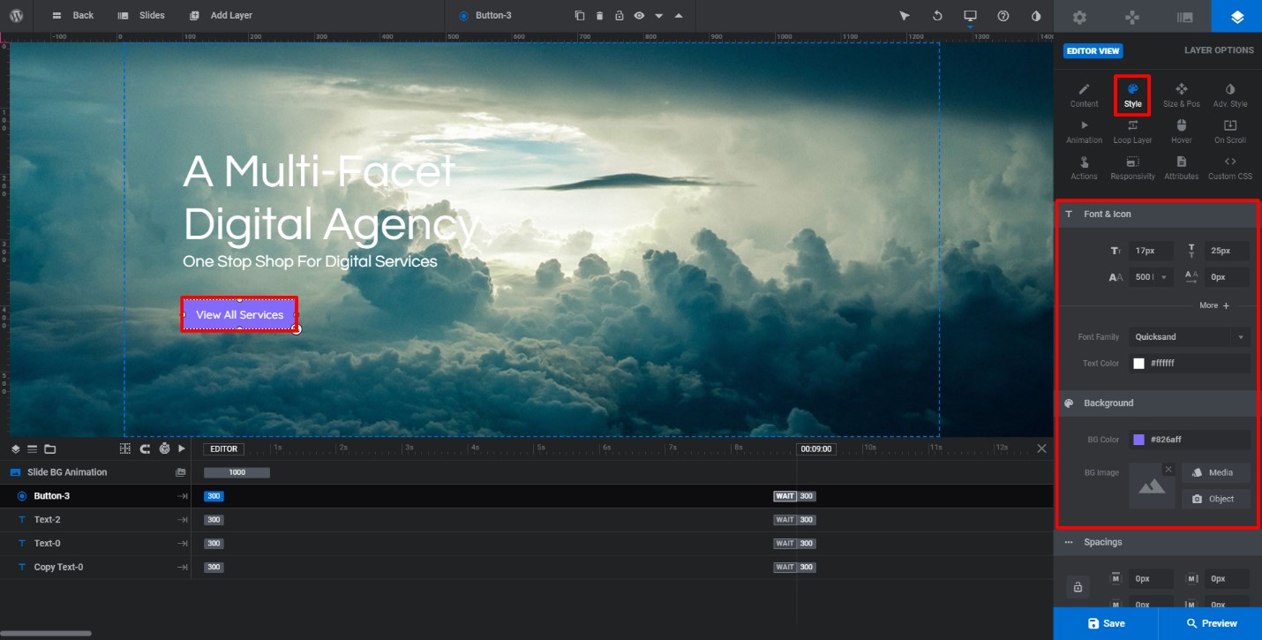
After editing content, click on style, size and other options (if required) to make other changes.
In style panel, you can edit font, size, colors etc.


Similarly, you can edit button layer as well. Double click on it update colors, button text, background etc.

